NAAN MUDHALVAN ASSIGNMENT – DIGITAL MARKETING

NAME : PRADEESH.S

EMAIL:pradeeshact29@gmail.com

NM ID : **aut23ec126**

ASSIGNMENT – 1

1. Create a blog or website using blogger and wordpress. Blog -

LINK : [https://tamilclasheís.blogspot.com/2023/10/bismi-chicken-stall-](https://tamilclashers.blogspot.com/2023/10/bismi-chicken-stall-bismi-nurturing.htmll) [bismi-nuítuíing.html](https://tamilclashers.blogspot.com/2023/10/bismi-chicken-stall-bismi-nurturing.htmll)

Screenshots:

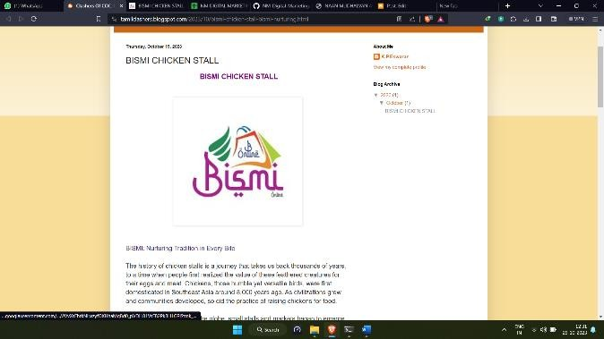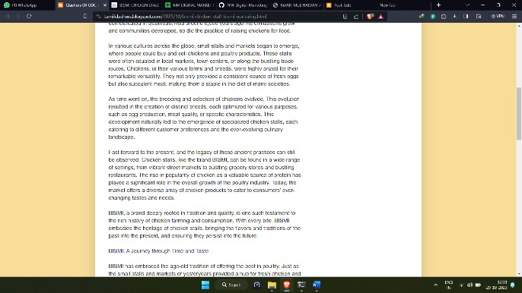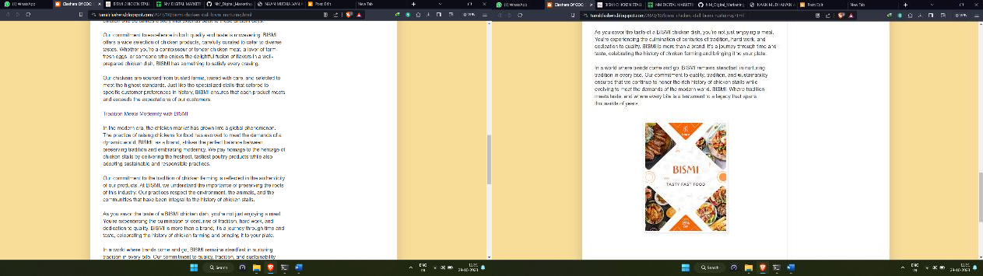

Wordpress Website – LINK :

<https://bismichickenstall.wordpress.com/2023/10/19/bismi-chicken-stall/>

Screenshots:

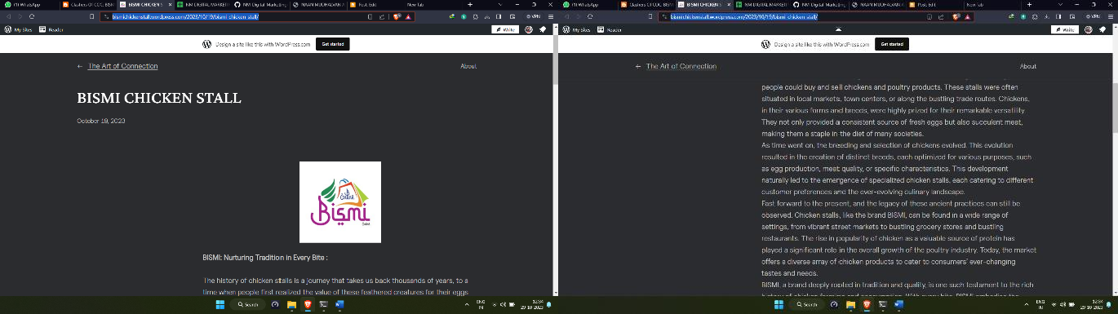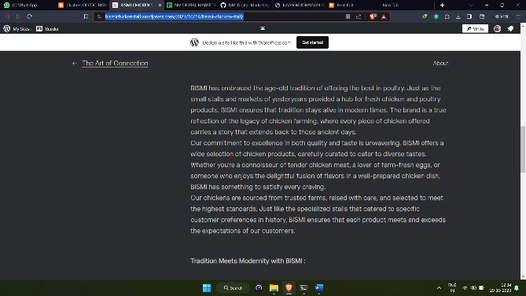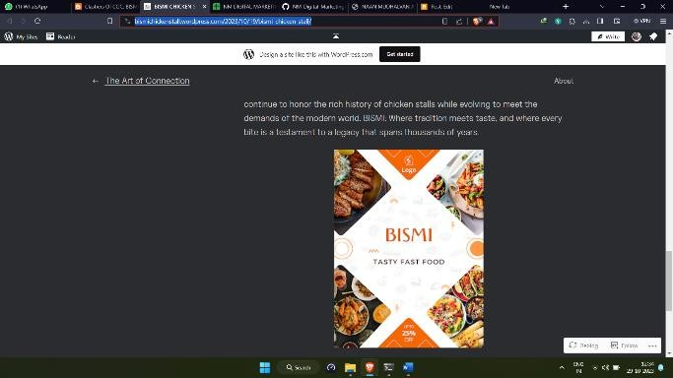

ASSIGNMENT-2

1. Create a new Facebook page and post a poster for the brand. LINK:

http[s://w](http://www.facebook.com/bismichickenstall)ww.f[acebook.com/bismichickenstall](http://www.facebook.com/bismichickenstall)

Screenshots:

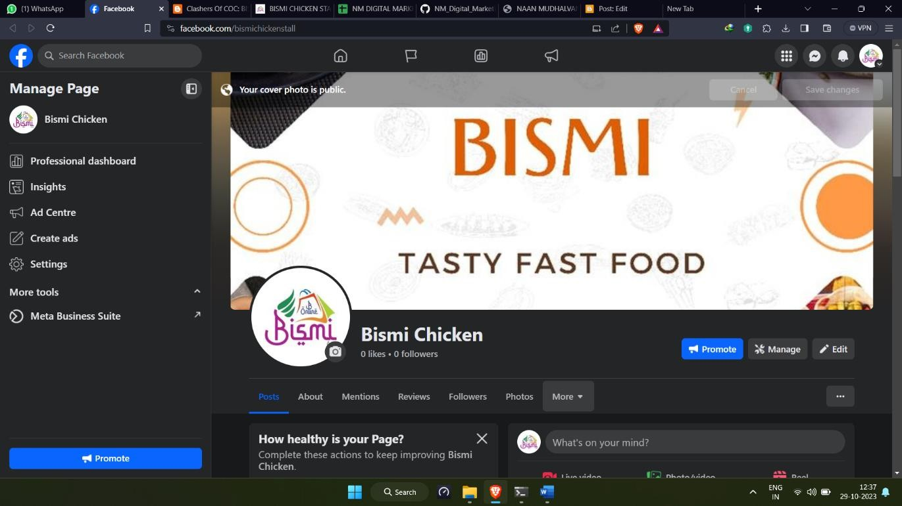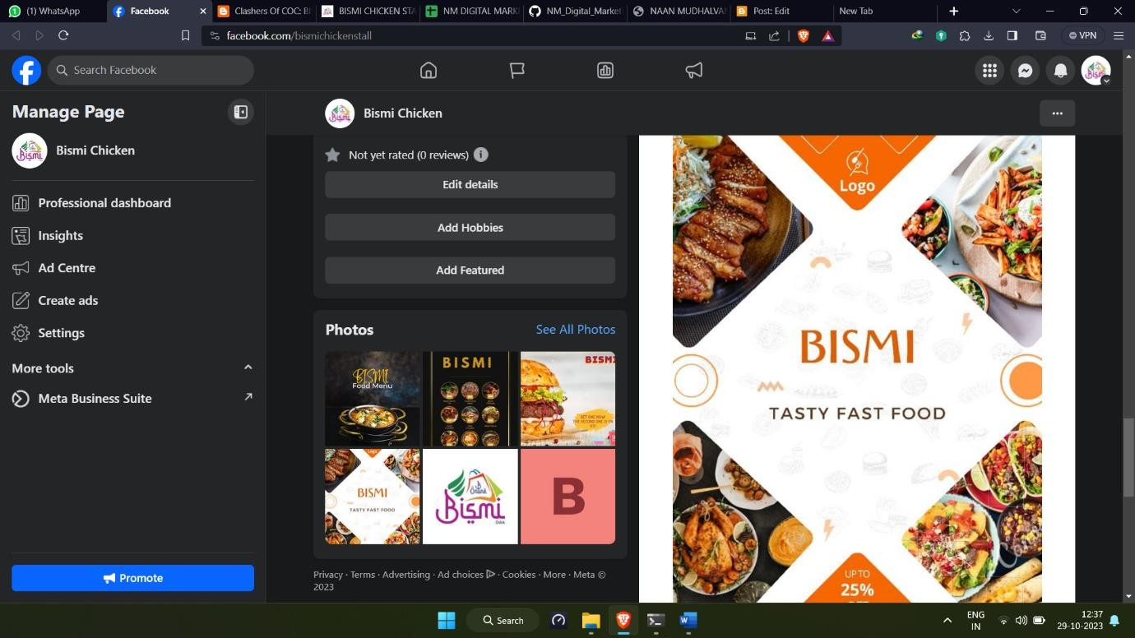

ASSIGNMENT – 3

1. Create and design a social media advertisement poster using Canva

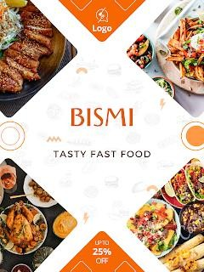

ASSIGNMENT – 4

1. Create email newsletter design using Mailchimp LINK:

https://us21.admin.mailchimp.com/campaigns/edit?id=12657214 Screenshots:

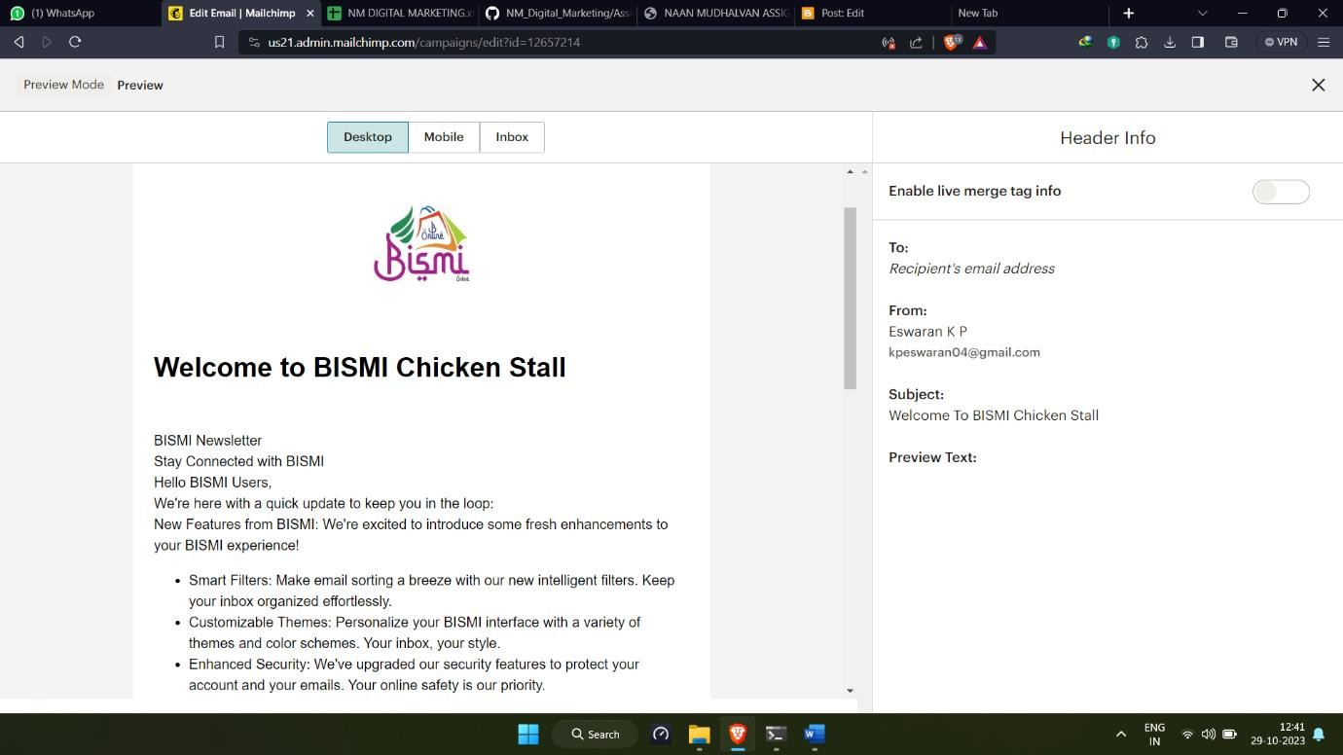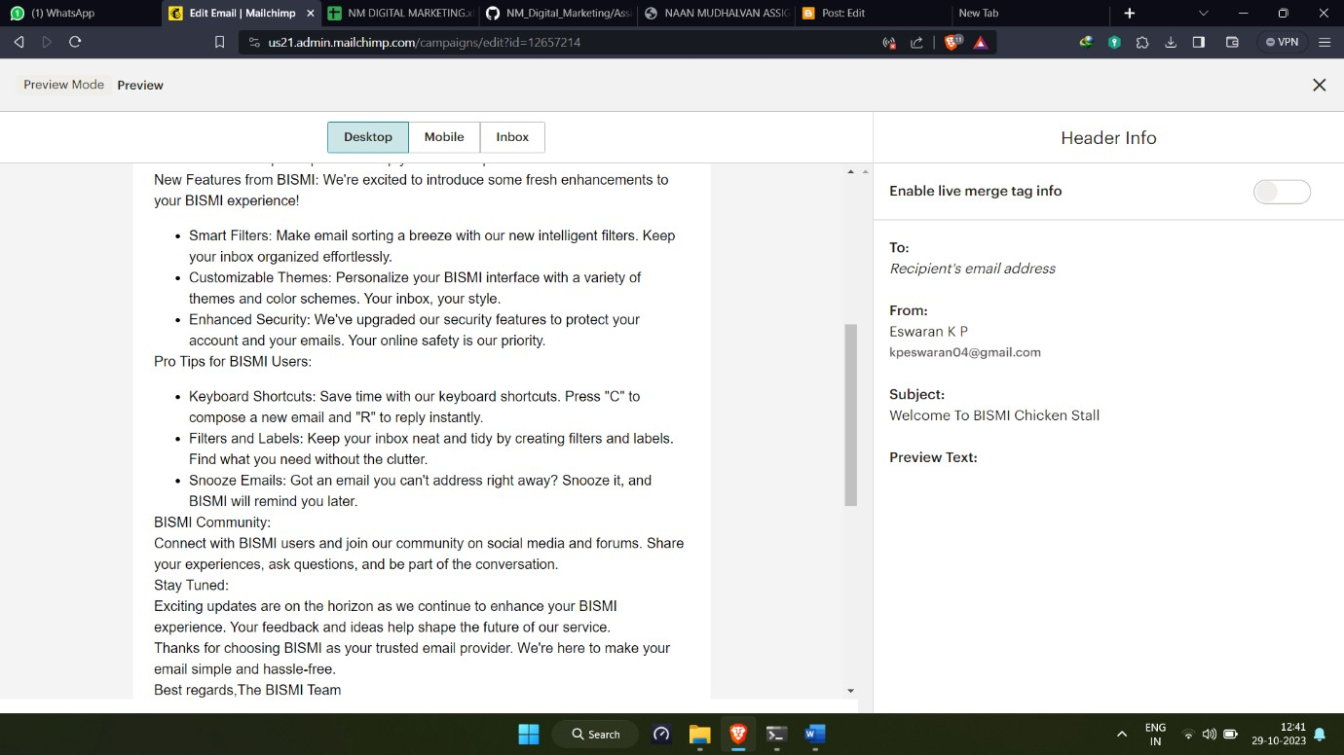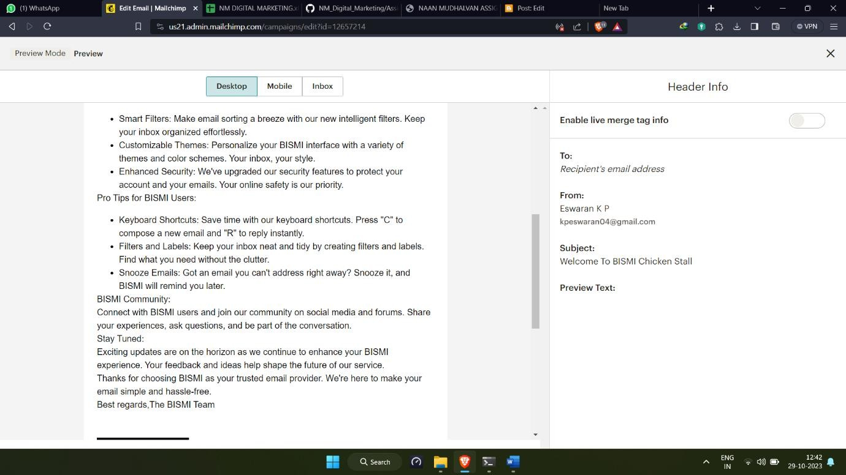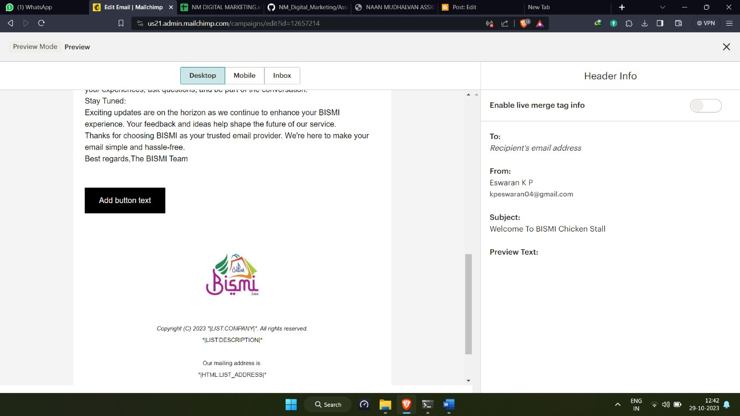

PRADEESH S B.E.

DIGITAL MARKETING NAAN MUDHALVAN